BILL OF MATERIALS - CAPEX

Table of Contents:

Section | Sub - Section | Description
1.BOM Form | 1.1 List of Templates Dashboard | List templates created by Part Number and Quantity
 | 1.2 Create Template | Integrate with product catalog from Inventory Management, Create dependencies and part validations
 | 1.3 Version History | Ability to duplicate and reuse an existing BOM template
2.BOM Dashboard | 2.1 Bill of Materials Dashboard | List templates created by site code and date
 | 2.2 Create Bill of Materials Form | Ability to create BIll of Material using existing templates
 | 2.3 Export Functionality | Download saved template as a PDF

1.1 List of Templates Dashboard:
- The List of Templates Dashboard consists of all created templates, displaying the email of the user who created or modified each template, along with the date and version information. Admins also have the option to delete templates
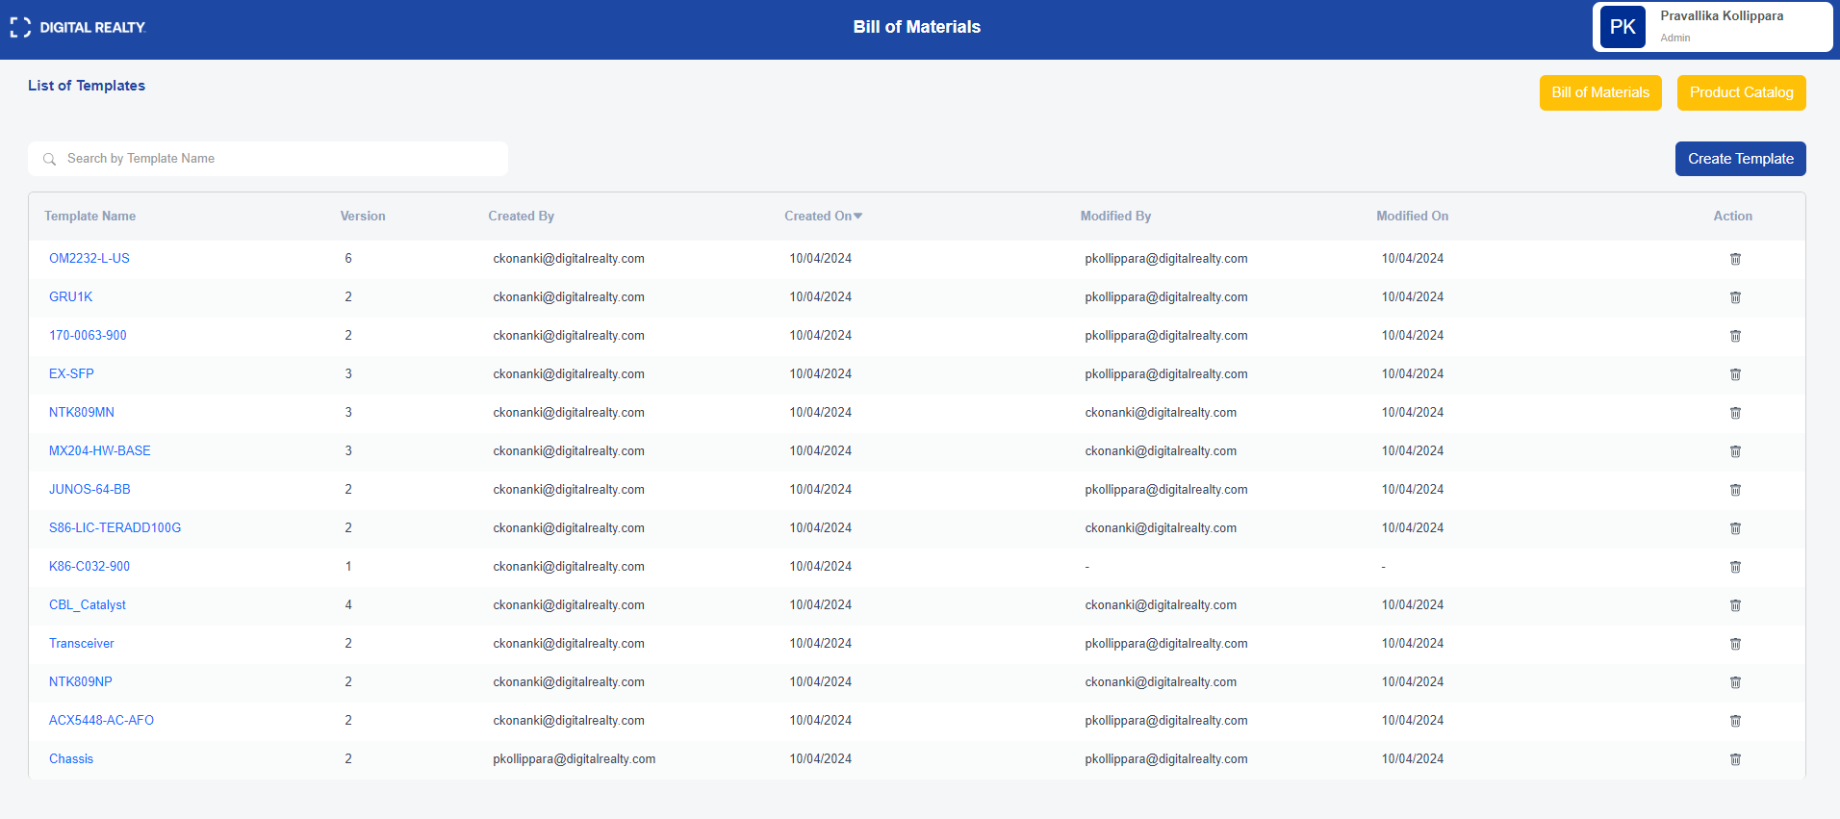
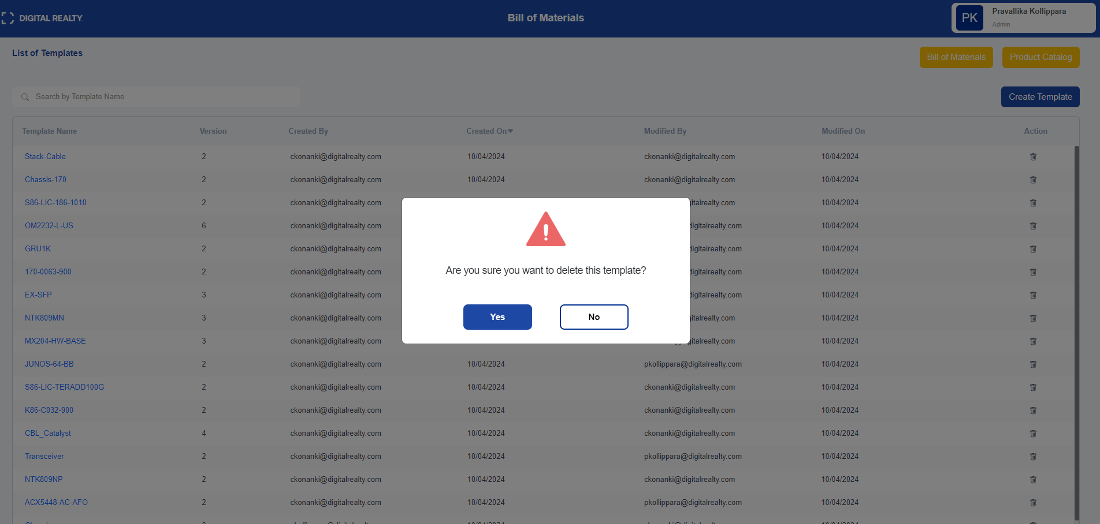
1.2 Create Template:
- Clicking on Create Template allows the user to select a part number from a dropdown, which displays details about the manufacturer and unit cost, along with the option to add the required quantity.
- Additionally, the user can link a part number to another part number for easier management
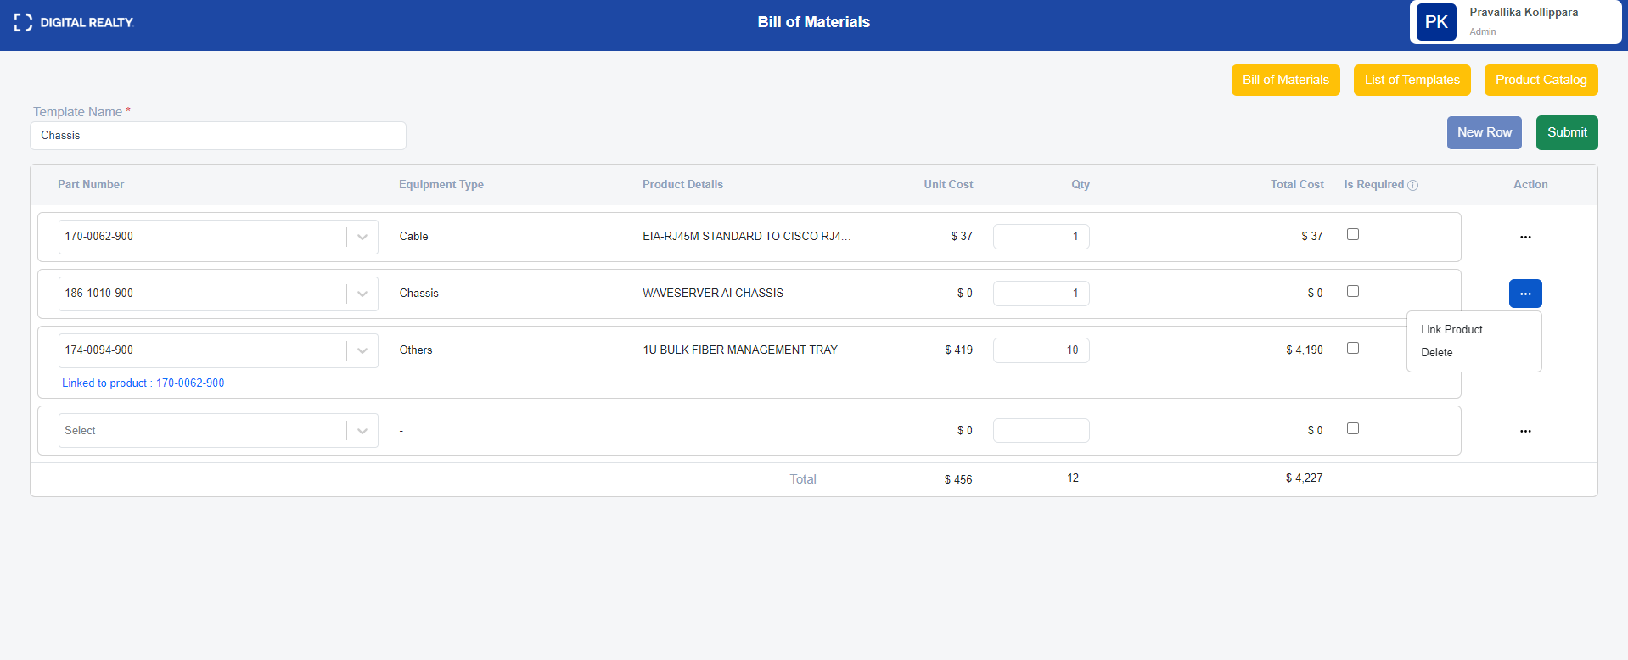
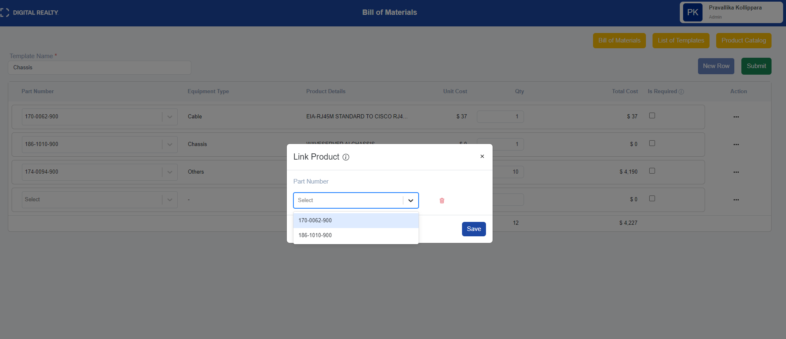

1.3 Version History:
- Version History displays the date and time along with the email of the user who created the entry. It also includes options to add comments and to duplicate/clone an existing template.
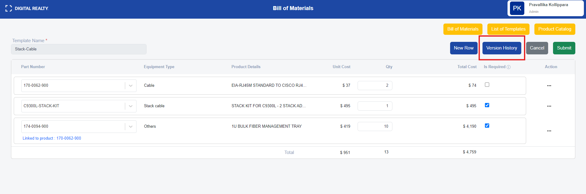
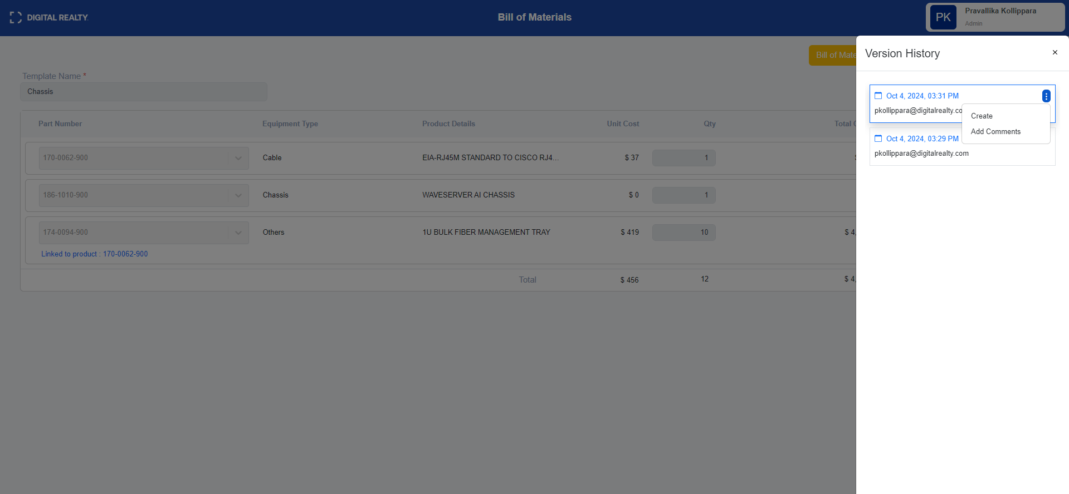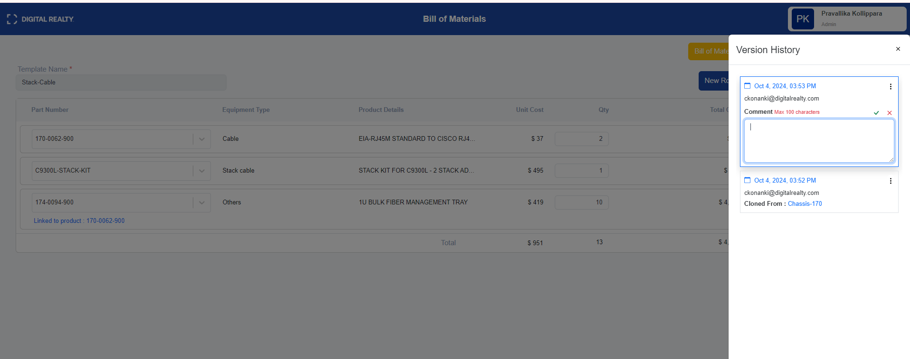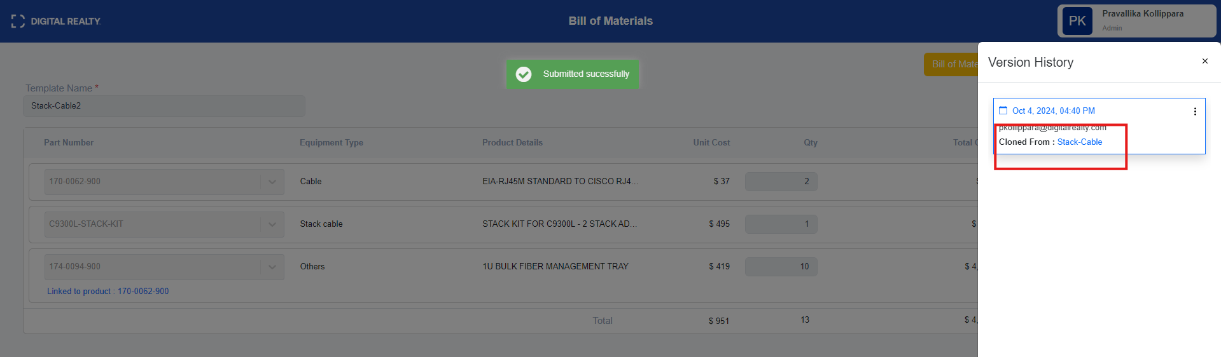
2.1 Bill of Materials Dashboard:
- The BOM Dashboard displays a list of created BOMs, including the created/modified date, user email, and the current stage of each BOM.
- There are two stages: Draft and Submitted. In the draft stage, users can edit the template and site code, while in the submitted stage, editing the template is not allowed, and users only have access to update quantities.
- Additionally, admins have the option to delete BOMs if they are in the draft stage
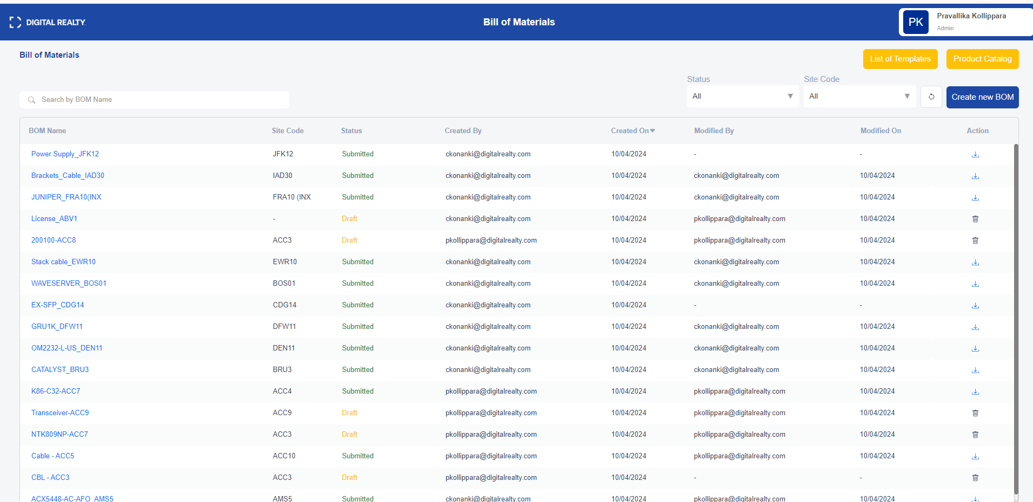
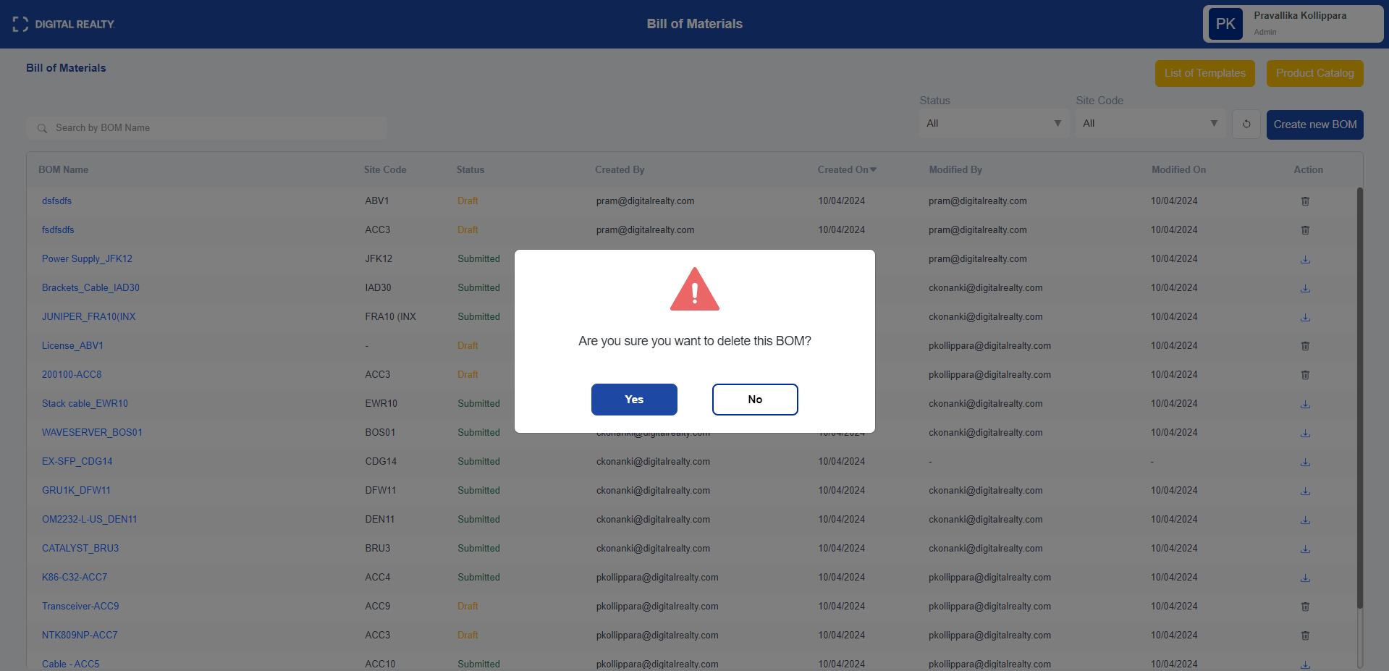

2.2 Create BOM Form:
- The Create BOM Form is used to create a BOM by selecting a template and specifying the site code for which the BOM is being created.
- It features auto-save functionality and a sync option. The sync option is available if the BOM is in draft stage, allowing users to sync updated template.
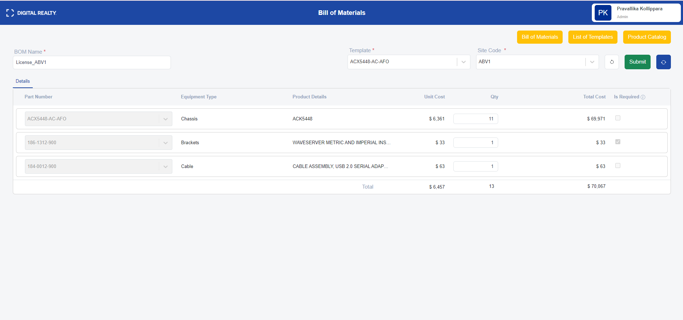
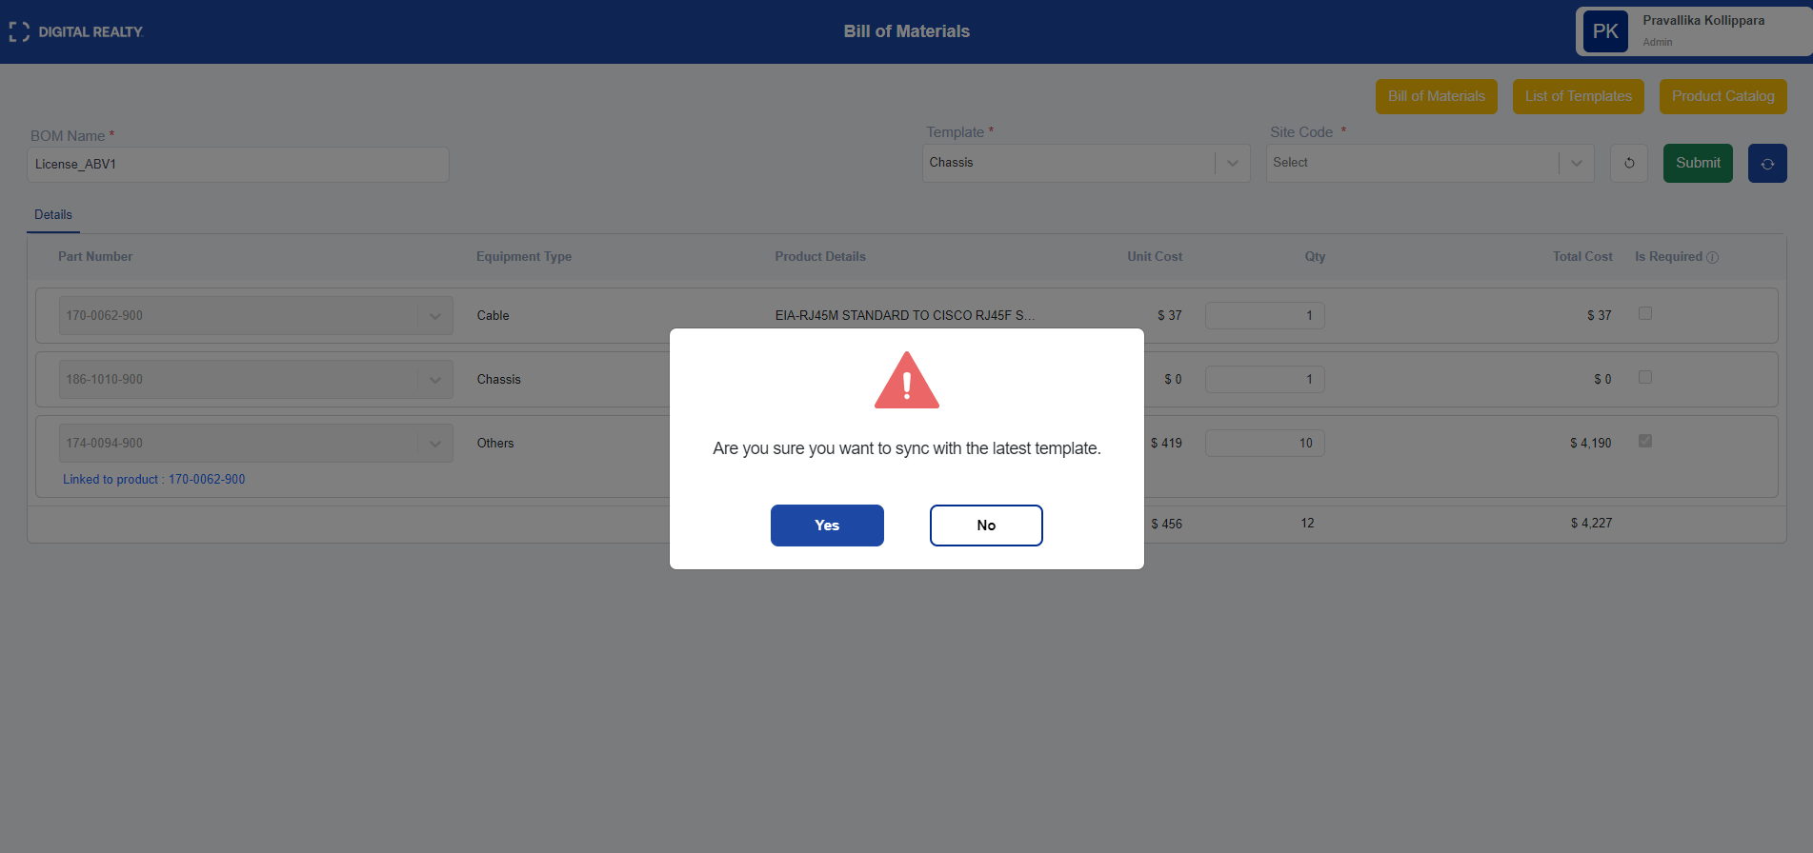
2.3 Export Functionality:
- For Submitted BOMs, an Export option is available. Clicking on it allows the user to download the BOM in PDF format.
